Table Of Contents
Cisco 831 Router and Cisco SOHO 91 Router Cabling and Setup Quick Start Guide
Cisco One-Year Limited Hardware Warranty Terms
Check Items Shipped with the Router
Connect the Router
Try to Connect to a Website
Configure the Router
SDM Configuration Instructions
CRWS Configuration Instructions
Congratulations! You Have Completed Setup
For More Information about your Router
Obtaining Documentation
Cisco.com
Documentation DVD
Ordering Documentation
Documentation Feedback
Cisco Product Security Overview
Reporting Security Problems in Cisco Products
Obtaining Technical Assistance
Cisco Technical Support Website
Submitting a Service Request
Definitions of Service Request Severity
Obtaining Additional Publications and Information

Cisco 831 Router and Cisco SOHO 91 Router Cabling and Setup Quick Start Guide

Quick Start Guide
• Cisco One-Year Limited Hardware Warranty Terms
• Check Items Shipped with the Router
• Connect the Router
• Try to Connect to a Website
• Configure the Router
• Congratulations! You Have Completed Setup
• Obtaining Documentation
• Documentation Feedback
• Cisco Product Security Overview
• Obtaining Technical Assistance
• Obtaining Additional Publications and Information

Cisco One-Year Limited Hardware Warranty Terms
There are special terms applicable to your hardware warranty and various services that you can use during the warranty period. Your formal Warranty Statement, including the warranties and license agreements applicable to Cisco software, is available on Cisco.com. Follow these steps to access and download the Cisco Information Packet and your warranty and license agreements from Cisco.com.
1. Launch your browser, and go to this URL:
http://www.cisco.com/univercd/cc/td/doc/es_inpck/cetrans.htm
The Warranties and License Agreements page appears.
2. To read the Cisco Information Packet, follow these steps:
a. Click the Information Packet Number field, and make sure that the part number 78-5235-03A0 is highlighted.
b. Select the language in which you would like to read the document.
c. Click Go.
The Cisco Limited Warranty and Software License page from the Information Packet appears.
d. Read the document online, or click the PDF icon to download and print the document in Adobe Portable Document Format (PDF).

Note You must have Adobe Acrobat Reader to view and print PDF files. You can download the reader from Adobe's website: http://www.adobe.com

3. To read translated and localized warranty information about your product, follow these steps:
a. Enter this part number in the Warranty Document Number field:
78-10747-01C0
b. Select the language in which you would like to view the document.
c. Click Go.
The Cisco warranty page appears.
d. Read the document online, or click the PDF icon to download and print the document in Adobe Portable Document Format (PDF).
You can also contact the Cisco service and support website for assistance:
http://www.cisco.com/public/Support_root.shtml.
Duration of Hardware Warranty
One (1) Year
Replacement, Repair, or Refund Policy for Hardware
Cisco or its service center will use commercially reasonable efforts to ship a replacement part within ten (10) working days after receipt of a Return Materials Authorization (RMA) request. Actual delivery times can vary, depending on the customer location.
Cisco reserves the right to refund the purchase price as its exclusive warranty remedy.
To Receive a Return Materials Authorization (RMA) Number
Contact the company from whom you purchased the product. If you purchased the product directly from Cisco, contact your Cisco Sales and Service Representative.
Complete the information below, and keep it for reference.
Company product purchased from
Company telephone number
Product model number
Product serial number
Maintenance contract number

Check Items Shipped with the Router
Do the following to verify that all required items were shipped with the router.

Step 1 Figure 1-1 shows the items included with the router. If any of the items is missing or damaged, contact your customer service representative.
Figure 1-1 Items Included with the Router
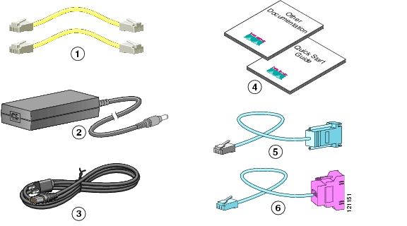
1 | Two yellow Ethernet cables | 4 | Product documentation
2 | Desktop power adapter | 5 | Light blue console cable (RJ-45-to-DB-9)
3 | Black power cord | 6 | Light blue async modem cable for dial backup and remote management (RJ-45-to-DB-25). (ordered separately)

Step 2 Locate the product serial number.
The serial number label for Cisco 831 router is located on the rear of the chassis, at the left edge.
Figure 1-2 Product Serial Number Location
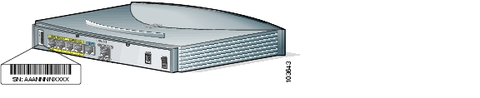

Connect the Router
Figure 1-3 shows a typical installation of a Cisco 831 router or SOHO 91 router.
Figure 1-3 Typical Cisco 831 or SOHO 91 Installation
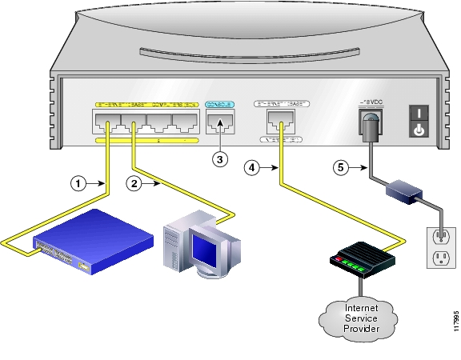

Step 1 If you are connecting more than 4 PCs to the router, connect the router to a switch or hub using a yellow Ethernet cable, as shown in Figure 1-3.
Step 2 To connect a PC directly to your router, do so as shown in Figure 1-3. Turn the PC off so that it will obtain an IP address from the router when it is turned on. You can connect additional PCs to the remaining numbered Ethernet ports.
Step 3 The console port is a service port to which you can connect a terminal or PC in order to configure the software by using the command-line interface (CLI) or to troubleshoot problems with the router. If you want access to the router console, connect a PC or terminal to the Console port. For more information refer to the Cisco 831 and SOHO 91 Hardware Installation Guide.

Note By connecting the console port to an asynchronous modem using the optional SOHO/800 series router modem cable, you can add dial backup and remote management capabilities to the router. Refer to the Cisco 831 Router and SOHO 91 Router Hardware Installation Guide for more information.

Step 4 Connect the second yellow Ethernet cable between the router's Ethernet Internet port and an available port on an installed DSL, cable, or long-reach Ethernet modem as shown in Figure 1-3.
Follow the instructions provided with your broadband modem to determine which port on the modem to connect to. Turn on the broadband modem if it is not already turned on.
Step 5 Connect power to the router as shown in Figure 1-3 and turn on the router. Be sure to use the power supply that was shipped with the router.
The green OK LED on the front panel of the router lights when you connect the router to a power source. The router is now ready to be used.
If the green OK LED does not turn on, refer to the "Troubleshooting the Router" chapter in the Cisco 831 and SOHO 91 Routers Hardware Installation Guide.

The Cisco 831 and SOHO 91 Hardware Installation Guide contains more detailed connection instructions.

Try to Connect to a Website
Log on to a PC that is connected to the router, open a web browser, and connect to a website. If you successfully access a website, you do not need to change the configuration and you have completed setup. If you cannot access a website, follow the steps in Configure the Router.

Configure the Router
Your router was shipped with a web-based configuration tool that you run from a web browser.

SDM Configuration Instructions
If the Cisco Router and Security Device Manager (SDM) Quick Start Guide was included in your accessory kit, Cisco Router and Security Device Manager (SDM) is loaded on your router. Refer to that document to configure your Cisco 831 router.
The following link contains more information about SDM, including release notes and other SDM documentation.
www.cisco.com/go/sdm

Note SDM is not shipped with SOHO 91 Routers.

CRWS Configuration Instructions
If you did not receive the Cisco Router and Security Device Manager (SDM) Quick Start Guide, Cisco Router Web Setup (CRWS) is loaded on your router. These instructions show you how to configure your router using CRWS. The CRWS software runs on Netscape versions 3.0 through 4.7, and on Internet Explorer version 4.0 or later.

Step 1 Start, or restart, a PC connected to one of the built-in switch ports (1, 2, 3, or 4) on the router.
Step 2 Open a web browser. Make sure that the browser is set to work in online mode.
•In Internet Explorer, click the File menu, and verify that the "work offline" option is unchecked.
•In Netscape, the default selection in the File menu is set to work online.
Step 3 Type in the universal resource locator (URL) shown in Figure 1-4.
Figure 1-4 Type in the URL http://10.10.10.1
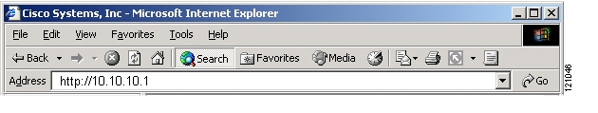
The CRWS dashboard page ( Figure 1-5) should appear after one or two minutes.
Figure 1-5 CRWS Dashboard Page
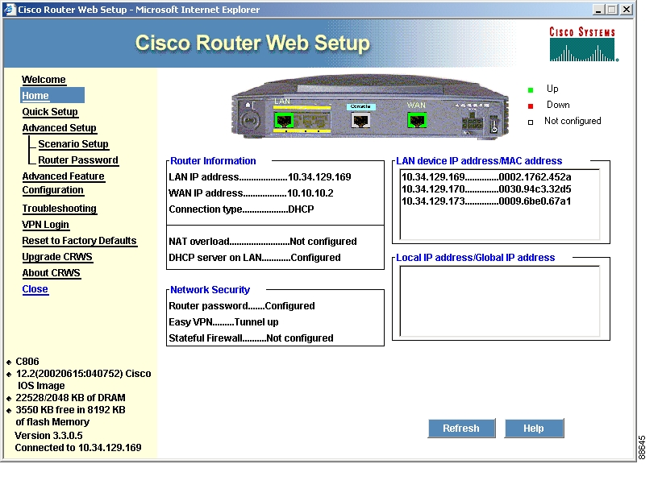

Tip If the CRWS dashboard page does not appear when you enter the URL http://10.10.10.1, test the connection between the PC and the router by doing the following:
•Check that the OK LED on the router is on, and check the cable connection between the router and the PC.
•If the CRWS home page still does not appear, verify that the web browser's "work offline" option is disabled.
•If the web page still does not appear, verify that the PC is configured to automatically receive an IP address. Select Start/Run, type winipcfg in the Run window, and examine the address in the IP address field. The address should be in the format 10.10.10.X, in which X is a number that is 2 or greater; for example, 10.10.10.2 or 10.10.10.3. If the IP address is not in this format, Follow the instructions in the Tip to configure the PC to obtain an IP address automatically. Then start CRWS again.

Step 4 If you have no special configuration requirements, click the Router Setup link on the home page, and then click Quick Setup. Then, enter the username and password provided to you by your Internet service provider, and follow the instructions that appear in the page that is displayed.
Step 5 If you need to configure special features such as Network Address Translation (NAT), click the appropriate links on the home page, and complete the configuration screens.
Step 6 Click the Router Password link on the home page, and set a password for the router.
Step 7 Select Start/Run, and type winipcfg in the Open field of the Run window. When the IP Config window appears, click Release, and then click Renew to release and renew the PC's IP address.
Alternatively, open the Run window, and enter ipconfig /release to release the PC's IP address. Then enter ipconfig /renew to renew the IP address of the PC.
Step 8 Open a web browser on the PC, and connect to a website. If you can connect to a website, you have completed setup.

Tip If you could not start CRWS, your PC might not be configured to obtain an IP address automatically. You can use this information if your PC is running Microsoft Windows NT or Microsoft Windows 95, 98, or 2000. If the PC is running a different version of Microsoft Windows, refer to the documentation that came with the PC.
1. Start the PC, and open the Control Panel.
2. Click the Network icon to display the Network window.
3. Verify that TCP/IP has been added and associated with the Ethernet adapter. TCP/IP is shown as a cable icon in the Configuration window on Microsoft Windows 95, 98, 2000, Windows ME, and Windows XP and as a cable icon in the Protocol window on Microsoft Windows NT. If the icon is not visible, click Add, and add Microsoft TCP/IP.
4. To verify that the PC is configured to obtain an IP address automatically, click the TCP/IP cable icon, and select the IP address tab in the TCP/IP Properties window. Check Obtain an IP address from a DHCP server if it is not checked. The IP address and Subnet mask fields should be grayed out.
5. To accept all changes and exit this window, click OK. Then click OK in the Network window.
6. If you are prompted, click Yes to reboot the PC.
7. Return to Step 3 in the "Configure the Router" section.
For more information on how to configure TCP/IP, refer to the Cisco Router Web Setup Troubleshooting Guide, which is available on Cisco.com.

Congratulations! You Have Completed Setup
If you were able to connect to a website, you have completed the cabling and setup of your router, and you can continue to use it to access the Internet. If you need to configure more features, click the CRWS link for the feature you need to configure, and enter configuration values for the router.

For More Information about your Router
Refer to the following documents for more information:
•Cisco 831 Router and SOHO 91 Router Hardware Installation Guide—Provides detailed cabling and hardware information for the Cisco 836 and SOHO 96 routers.
•Cisco 800 Series Router Software Configuration Guide—Provides detailed configuration instructions for the Cisco 800 series routers.
•Regulatory Compliance and Safety Information for Cisco 800 Series and SOHO Series Routers—Provides international regulatory and safety compliance information for all Cisco 800 series routers and Cisco SOHO series routers.

Obtaining Documentation
Cisco documentation and additional literature are available on Cisco.com. Cisco also provides several ways to obtain technical assistance and other technical resources. These sections explain how to obtain technical information from Cisco Systems.

Cisco.com
You can access the most current Cisco documentation at this URL:
http://www.cisco.com/univercd/home/home.htm
You can access the Cisco website at this URL:
http://www.cisco.com
You can access international Cisco websites at this URL:
http://www.cisco.com/public/countries_languages.shtml

Documentation DVD
Cisco documentation and additional literature are available in a Documentation DVD package, which may have shipped with your product. The Documentation DVD is updated regularly and may be more current than printed documentation. The Documentation DVD package is available as a single unit.
Registered Cisco.com users (Cisco direct customers) can order a Cisco Documentation DVD (product number DOC-DOCDVD=) from the Ordering tool or Cisco Marketplace.
Cisco Ordering tool:
http://www.cisco.com/en/US/partner/ordering/index.shtml
Cisco Marketplace:
http://www.cisco.com/go/marketplace/

Ordering Documentation
You can find instructions for ordering documentation at this URL:
http://www.cisco.com/univercd/cc/td/doc/es_inpck/pdi.htm
You can order Cisco documentation in these ways:
•Registered Cisco.com users (Cisco direct customers) can order Cisco product documentation from the Ordering tool:
http://www.cisco.com/en/US/partner/ordering/index.shtml
•Nonregistered Cisco.com users can order documentation through a local account representative by calling Cisco Systems Corporate Headquarters (California, USA) at 408 526-7208 or, elsewhere in North America, by calling 1 800 553-NETS (6387).

Documentation Feedback
You can send comments about technical documentation to bug-doc@cisco.com.
You can submit comments by using the response card (if present) behind the front cover of your document or by writing to the following address:
Cisco Systems
Attn: Customer Document Ordering
170 West Tasman Drive
San Jose, CA 95134-9883
We appreciate your comments.

Cisco Product Security Overview
Cisco provides a free online Security Vulnerability Policy portal at this URL:
http://www.cisco.com/en/US/products/products_security_vulnerability_policy.html
From this site, you can perform these tasks:
•Report security vulnerabilities in Cisco products.
•Obtain assistance with security incidents that involve Cisco products.
•Register to receive security information from Cisco.
A current list of security advisories and notices for Cisco products is available at this URL:
http://www.cisco.com/go/psirt
If you prefer to see advisories and notices as they are updated in real time, you can access a Product Security Incident Response Team Really Simple Syndication (PSIRT RSS) feed from this URL:
http://www.cisco.com/en/US/products/products_psirt_rss_feed.html

Reporting Security Problems in Cisco Products
Cisco is committed to delivering secure products. We test our products internally before we release them, and we strive to correct all vulnerabilities quickly. If you think that you might have identified a vulnerability in a Cisco product, contact PSIRT:
•Emergencies — security-alert@cisco.com
•Nonemergencies — psirt@cisco.com

Tip We encourage you to use Pretty Good Privacy (PGP) or a compatible product to encrypt any sensitive information that you send to Cisco. PSIRT can work from encrypted information that is compatible with PGP versions 2.x through 8.x.
Never use a revoked or an expired encryption key. The correct public key to use in your correspondence with PSIRT is the one that has the most recent creation date in this public key server list:
http://pgp.mit.edu:11371/pks/lookup?search=psirt%40cisco.com&op=index&exact=on

In an emergency, you can also reach PSIRT by telephone:
•1 877 228-7302
•1 408 525-6532

Obtaining Technical Assistance
For all customers, partners, resellers, and distributors who hold valid Cisco service contracts, Cisco Technical Support provides 24-hour-a-day, award-winning technical assistance. The Cisco Technical Support Website on Cisco.com features extensive online support resources. In addition, Cisco Technical Assistance Center (TAC) engineers provide telephone support. If you do not hold a valid Cisco service contract, contact your reseller.

Cisco Technical Support Website
The Cisco Technical Support Website provides online documents and tools for troubleshooting and resolving technical issues with Cisco products and technologies. The website is available 24 hours a day, 365 days a year, at this URL:
http://www.cisco.com/techsupport
Access to all tools on the Cisco Technical Support Website requires a Cisco.com user ID and password. If you have a valid service contract but do not have a user ID or password, you can register at this URL:
http://tools.cisco.com/RPF/register/register.do

Note Use the Cisco Product Identification (CPI) tool to locate your product serial number before submitting a web or phone request for service. You can access the CPI tool from the Cisco Technical Support Website by clicking the Tools & Resources link under Documentation & Tools. Choose Cisco Product Identification Tool from the Alphabetical Index drop-down list, or click the Cisco Product Identification Tool link under Alerts & RMAs. The CPI tool offers three search options: by product ID or model name; by tree view; or for certain products, by copying and pasting show command output. Search results show an illustration of your product with the serial number label location highlighted. Locate the serial number label on your product and record the information before placing a service call.

Submitting a Service Request
Using the online TAC Service Request Tool is the fastest way to open S3 and S4 service requests. (S3 and S4 service requests are those in which your network is minimally impaired or for which you require product information.) After you describe your situation, the TAC Service Request Tool provides recommended solutions. If your issue is not resolved using the recommended resources, your service request is assigned to a Cisco TAC engineer. The TAC Service Request Tool is located at this URL:
http://www.cisco.com/techsupport/servicerequest
For S1 or S2 service requests or if you do not have Internet access, contact the Cisco TAC by telephone. (S1 or S2 service requests are those in which your production network is down or severely degraded.) Cisco TAC engineers are assigned immediately to S1 and S2 service requests to help keep your business operations running smoothly.
To open a service request by telephone, use one of the following numbers:
Asia-Pacific: +61 2 8446 7411 (Australia: 1 800 805 227)
EMEA: +32 2 704 55 55
USA: 1 800 553-2447
For a complete list of Cisco TAC contacts, go to this URL:
http://www.cisco.com/techsupport/contacts

Definitions of Service Request Severity
To ensure that all service requests are reported in a standard format, Cisco has established severity definitions.
Severity 1 (S1)—Your network is "down," or there is a critical impact to your business operations. You and Cisco will commit all necessary resources around the clock to resolve the situation.
Severity 2 (S2)—Operation of an existing network is severely degraded, or significant aspects of your business operation are negatively affected by inadequate performance of Cisco products. You and Cisco will commit full-time resources during normal business hours to resolve the situation.
Severity 3 (S3)—Operational performance of your network is impaired, but most business operations remain functional. You and Cisco will commit resources during normal business hours to restore service to satisfactory levels.
Severity 4 (S4)—You require information or assistance with Cisco product capabilities, installation, or configuration. There is little or no effect on your business operations.

Obtaining Additional Publications and Information
Information about Cisco products, technologies, and network solutions is available from various online and printed sources.
•Cisco Marketplace provides a variety of Cisco books, reference guides, and logo merchandise. Visit Cisco Marketplace, the company store, at this URL:
http://www.cisco.com/go/marketplace/
•Cisco Press publishes a wide range of general networking, training and certification titles. Both new and experienced users will benefit from these publications. For current Cisco Press titles and other information, go to Cisco Press at this URL:
http://www.ciscopress.com
•Packet magazine is the Cisco Systems technical user magazine for maximizing Internet and networking investments. Each quarter, Packet delivers coverage of the latest industry trends, technology breakthroughs, and Cisco products and solutions, as well as network deployment and troubleshooting tips, configuration examples, customer case studies, certification and training information, and links to scores of in-depth online resources. You can access Packet magazine at this URL:
http://www.cisco.com/packet
•iQ Magazine is the quarterly publication from Cisco Systems designed to help growing companies learn how they can use technology to increase revenue, streamline their business, and expand services. The publication identifies the challenges facing these companies and the technologies to help solve them, using real-world case studies and business strategies to help readers make sound technology investment decisions. You can access iQ Magazine at this URL:
http://www.cisco.com/go/iqmagazine
•Internet Protocol Journal is a quarterly journal published by Cisco Systems for engineering professionals involved in designing, developing, and operating public and private internets and intranets. You can access the Internet Protocol Journal at this URL:
http://www.cisco.com/ipj
•World-class networking training is available from Cisco. You can view current offerings at this URL:
http://www.cisco.com/en/US/learning/index.html

